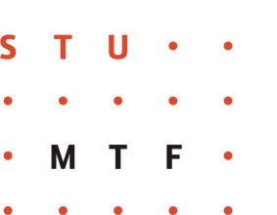


SLOVAK UNIVERSITY OF TECHNOLOGY IN BRATISLAVA

Faculty of Materials Science and Technology in Trnava

Institute of Industrial Engineering, Management and Quality

in cooperation with the Slovak Society for Quality

are organizing the seminar under the auspices

of Professor Dr Oliver Moravčík

the dean of MTF STU Trnava

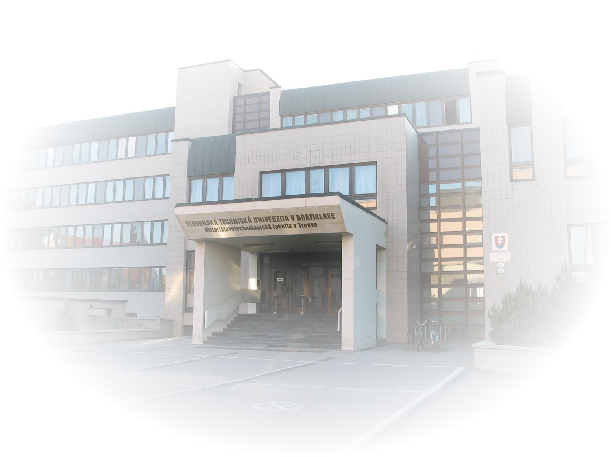
4th International Scientific Seminar

12th – 13th April 2011
MTF STU, Paulínska 16, Trnava, SR
www.mtf.stuba.sk
Professional guarantee of the seminar:
Assoc. prof. Iveta Paulová, PhD. MTF STU Trnava, SR
Program committee:
prof. Jaroslav Nenadál, PhD., VŠB - Technical University of Ostrava, CR
prof. Jiří Plura, PhD., VŠB - Technical University of Ostrava, CR
Assoc. prof . Petr Briš, PhD., Tomas Bata University in Zlín, CR
prof. Jaroslav Komárek, PhD, Karel Englis College, Brno, CR
prof. Stanislaw Borkowski, Faculty of Management
of Czestochowa University of Technology, Czestochowa, Poland
Assoc. prof. Robert Ulevicz, Faculty of Management
of Czestochowa University of Technology, Czestochowa, Poland
prof. Mladen Figurič, PhD., Šumarski fakultet, Zagreb, Croatia
prof. Denis Jelačič, PhD., University of Zagreb, Croatia
prof. Vojcech Lis, PhD., Academia Rolnicza, Poznaň, Poland
prof. Vladimir Pavlovich Shalaev, Faculty of Social Technologies in Mari State Technical University, Russia
prof. Bella Iles,, University of Miskolc, Faculty of Mechanical Engineering and Information Technology, Miskolc, Hungary
Ass. prof. DI. Dr. Sebastian Alber, WU Wien, Austria
prof. Edita Hekelová, PhD., Faculty of Mechanical Engineering STU, Bratislava, SR
prof. Kristína Zgodavová, PhD., TnUAD Trenčín, SR
prof. Anna Šatanová, PhD., Technical University in Zvolen, SR
Assoc. prof. Miroslav Hrnčiar, PhD., Faculty of Management Science and Informatics ZU, Žilina, SR; Slovak Society for Quality, SR
Assoc. prof. Miloš Čambál, PhD., MTF STU, Trnava, SR
Assoc. prof. Iveta Paulová, PhD., MTF STU, Trnava, SR
MSc. Marta Kučerová, PhD., MTF STU, Trnava, SR
MSc. Miroslava Mĺkva, PhD., MTF STU, Trnava, SR
MSc. Jaromíra Vaňová, PhD., MTF STU, Trnava, SR
MSc. Jana Urdziková, PhD., MTF STU, Trnava, SR
MSc. Katarína Škůrková - Lestyanszká, PhD., MTF STU, Trnava, SR
Organizing committee of the seminar:
MSc. Marta Kučerová, PhD.
MSc. Miroslava Mĺkva, PhD.
MSc. Jaromíra Vaňová, PhD.
MSc. Jana Urdziková, PhD.
MSc. Katarína Škůrková - Lestyanszká, PhD.
Seminar proceedings reviewers:
Prof. Kristína Zgodavová, PhD.
Assoc. prof. Iveta Paulová, PhD.
Assoc. prof. Miroslav Hrnčiar, PhD.

Topic of the seminar:
New trends in quality management

Aim of the seminar:
- New market requirements and tend of quality management.
- The exchange of theoretical and practical knowledge from the point of view of actual and future quality management trends.
- Comparison of content and teaching methodology courses aimed at the production quality, quality management, quality engineering and relevant teaching in related study programs and direction design.
- Presentation of practical knowledge of graduates in the study program production quality.
- Presentation of the PhD papers of doctoral students with focus on production quality, management and engineering quality.
Seminar languages: Slovak, Czech, Polish, English, Russian.
Preliminary seminar schedule:
1st day of the seminar – 12th April 2011
08.30 – 10.00 | registration
10.00 – 12.15 | meeting of the teachers from the following study programs the Production quality, Production quality engineering, resp. relative orientation, presentation of research results and teaching areas
12.15 – 13.00 | lunch
13.00 – 13.15 | opening speech by the director of Institute of Industrial Engineering, Management and Quality (Assoc. prof. Miloš Čambál, PhD.) and president of the Slovak Society for Quality (Assoc.prof. Miroslav Hrnčiar, PhD.)
13.15 – 15.15 | working meetings - invited lectures
15.15 – 15.30 | break
15.30 – 18.00 | working meetings in 2 sections:
1st section - options and direction of quality management in relation to the market requirements
2nd section - exchange of theoretical and practical knowledge in the field of quality management
19.00 | brainstorming (social evening)

2nd day of the seminar – 13th April 2011
08.30 – 09.30 | registration
09.30 – 11.30 | presentation of knowledge of business practice graduates study program the Production quality
11.30 – 11.45 | break
11.45 – 13.45 | presentation of the PhD papers of doctoral students with focus on production quality, management and engineering quality
13.45 – 14.00 | conclusion of the seminar
Deadlines:
Application form and abstract: | 05th March 2011
Advice about acceptance: | 10th March 2011
Sending for paper: | 05th April 2011
Payment of registration fee: | 05th April 2011
REGISTRATION FEE: 70 €
The fee will cover expenses for the Seminar proceedings, technical and organizing costs, refreshments (including lunch), brainstorming (social evening).

The fee for publication without the contribution of participation in the Seminar: 30 €

MTF STU is subject to VAT.

Registration fee must be paid by 05th April 2011.

Payments to participants from abroad:
IBAN: | SK2281800000007000081412
Variable symbol: | 142011
Constant symbol: | 0308
SWIFT: | SUBASKBX
Specific symbol: | name of the participant for which they pay registration fee
The need for tax document (invoice) specifies the payment information.
Bank name: Všeobecná úverová banka, Mlynské Nivy 1, 82990 Bratislava, SR
Name and address of the payee:
Slovak University of Technology in Bratislava
Faculty of Materials Science and Technology STU in Trnava
Paulínska 16, 917 24 Trnava, SR
IČO: 00397687
DIČ: 2020845255
IČ DPH: SK2020845255
PAYMENTS TO PARTICIPANTS OF SR:
Treasury: | 7000081412/8180
Variable symbol: | 142011
Constant symbol: | 0308
Specific symbol: | name of the participant for which they pay registration fee
The need for tax document (invoice) specifies the payment information.

I hope that at the international scientific seminar "New Trends in Quality Management" you’ll can feel well and at the same time I invite you to on the following scientific conference
"Quality - focus on success"

Assoc. prof. Iveta Paulová, PhD.

Informations for authors:
- Article should be send in MS Word 97-2003 format via email: miroslava.mlkva@stuba.sk
and at the same time in written from (hard copy) by mail to the address:
Ing. Miroslava Mĺkva, PhD.
ÚPMK MTF STU
Paulínska 16
917 24 Trnava, SR
- While editing the article use Times New Roman CE font, lining 1, 2,5 cm all margins.
- Content arrangements:
- title of the article (size 16, bold, centered)
- author’s name – without titles (size 12, bold, centered)
- abstract (summary in English, max. 5 lines, size 12, aligned margins)
- key words (size 12, aligned margins)
- text of the article (headings - size 14, bold, aligned to the left; text – size 12, aligned margins)
- author´s address (name with full acadimc degrees, address, e-mail)
- The extent of the article is limited to max. 5 pages including attachments and literature.

The articles will be issued on CD and will be reviewed.

Choices actively the articles presented at the conference will be published in a scientific journal Forum of manager http://www.mtf.stuba.sk/generate_page.php?page_id=5278 or Quality Innovation Prosperity/Kvalita Inovácia Prosperita http:///www.qip-journal.eu

Accommodation information:

Accommodation fee is covered by attendees.

Attendees are providing for accommodation in hotel individual.

Hotel BARBAKAN | Štefánikova 11, Trnava, SR  Phone: +421 (0)33 5511 847  web: www.barbakan-trnava.sk
Hotel DREAM | Kapitulská 12, Trnava, SR  Phone: +421 (0)33 5924 111  web: www.hoteldream.sk
Hotel IMPIQ | B.S. Timravy 2, Trnava, SR  Phone: +421 (0)33 555 55 55  e-mail: recepcia@impiq.sk  web: www.hotelimpiq.sk
Hotel INKA | V. Clementisa 13, Trnava, SR  Phone: +421 (0)33 590 51 11  email: inkatr@nextra.sk
Hotel LONDON | Kapitulská 5, Trnava, SR  Phone: +421 (0)33 534 05 86  email: recepcia@hotelondon.sk  web: www.hotellondon.sk
Hotel PHOENIX | Kapitulská 16, Trnava, SR  Phone: +421 (0)33 551 60 74  web: www.hotelphoenix.sk

