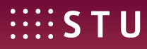

Confirmation on the termination of Erasmus+ mobility for traineeship

This confirmation is issued for and on the request of the Slovak University of Technology in Bratislava (SK BRATISL01).

Hereby we confirm, that Erasmus+ Mobility for traineeship of
student/graduate (full name):
born:
from the Slovak University of Technology in Bratislava, Slovakia (SK BRATISL01)
has terminated at the Institution:

on day: month: year:

Name of the signatory:
Post of the signatory:

Signature: …………………………………..

Date: ……………………………………….. Stamp:

