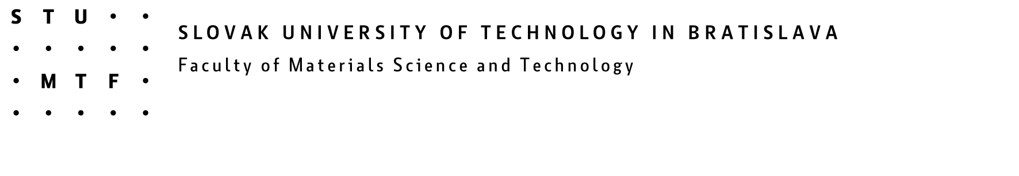

CO-MAT-TECH 2007
15th International Scientific Conference
Trnava, 18 -19 October 2007-07-05

INFORMATION

- In application form write the participants name (not the contribution authors)
- Acceptation letters will be sent after summarising the applications.
- Do not forget to write the reviewer´s name at the end of your contribution.
- Information on paper format at www.mtf.stuba.sk or contact Ing. Martin Duchoň (martin.duchon@stuba.sk).
- Each participant has to book a hotel room on his/her own. A choice of hotels and pensions available is listed in this information brochure.

Deadlines:

for sending application forms by15 September
for sending contributions in electronic version by 30 September 2007
for paying the conference fee by 30 September 2007

INSTRUCTIONS FOR THE CONTRIBUTIONS CO-MAT-TECH 2007

- Contribution can be written in English.
- Length of contributions: 6-12 pages, A4 paper in Word in doc. or rtf format.
- Detailed information on abstract and contribution including sample sets can find on www.mtf.stuba.sk, section CO-MAT-TECH 2007.
- Text layout: 1. Abstract – one page A4 (separately)
- Contribution layout: 1. Title of the contribution
2. Surname a first name of the autor/s
3. Author´s workplace and e-mail address
4. Text of the contribution
5. Reviewer´s name

INFORMATION:

Ing. Martin Duchoň e-mail: martin.duchoň@stuba.sk

