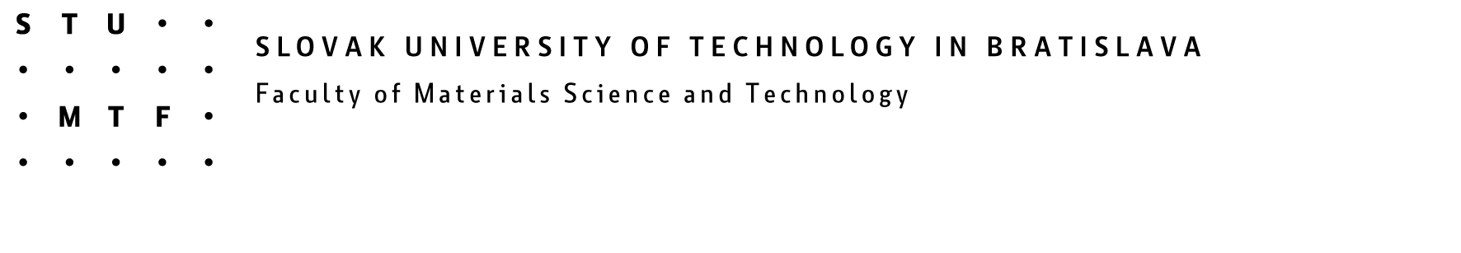

CO-MAT-TECH 2007
15th International Scientific Conference
Trnava, 18 -19 October 2007-07-05

PROGRAMME

18 October 2007

7.00 – 9.00 Registration
9.00 – 10.00 Official opening, plenary
10.00 – 12.00 Plenary lectures
12.00 – 13.00 Lunch break
13.00 -18.00 Lectures
19.30 Social event

19 October 2007

8.00 – 12.00 Lectures
12.00 Closing of the conference

The detailed Scientific Conference presentation schedule will be available at www.stuba.sk or web.mtf.stuba.sk minimum two weeks before the Scientific Conference.

